|  |  |  |  |
| --- | --- | --- | --- |
|  |  | |  |
|  |  |  |  |
| “synchro traffic”的图片搜索结果 |  | Synchro Scrubber Tool User Guide |
|  |  | |  |
|  | **© 2020 HDR, Inc. All Rights Reserved** | |  |

# Copyright & Disclaimer

This tool and its content is copyright of HDR, Inc. - © HDR, Inc. 2020. All rights reserved.

Any redistribution or reproduction of part or all of the contents in any form is prohibited.

You may not, except with our express written permission, distribute or commercially exploit the content. Nor may you transmit it or store it in any other website or other form of electronic retrieval system.

In no event, unless required by applicable law or agreed to in writing, shall HDR, Inc., or any person be liable for any loss, expense or damage, of any type or nature arising out of the use of, or inability to use this software or program, including, but not limited to, claims, suits or causes of action involving alleged infringement of copyrights, patents, trademarks, trade secrets, or unfair competition.

Contents

Copyright & Disclaimer 1

1. Introduction 3

2. Registration 4

3. Load Synchro Data 5

4. Comparison Result 8

# Introduction

The purpose of the Synchro Scrubber Tool is to compare inputs, movement delay, arterial travel time, and delay between two Synchro models. Another purpose of the tool is to check inputs for errors to determine if an incorrect value was entered.

# Registration

In order for the tool to work correctly, all Macros need to be enabled in Excel. Open an Excel file, click the “File” tab – “Options” – “Trust Center Settings” – “Macro Settings” and select “Enable all macros.”

The SYNScrubber Tool has a simple registration process. After opening the tool – “SYNScrubber_V3.0.xlsm”, an automatic window will pop-up requiring the user to send an email to David Petree ([David.Petree@hdrinc.com](mailto:David.Petree@hdrinc.com)) in order to obtain a license. (Figure 1)

After receiving the request, David will send the license in a reply email. Place the license file – “Product.key” in the same folder as the Scrubber tool. (Figure 2) After this is completed, the tool can be opened and used. Please note that if successfully registered, the original pop-up for registration will not come up again.

Figure 1. SYNScrubber Tool Registration Email Pop-up

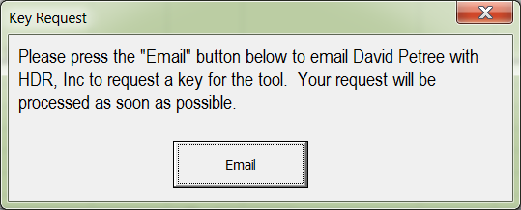

Figure 2. SYNScrubber Tool Folder

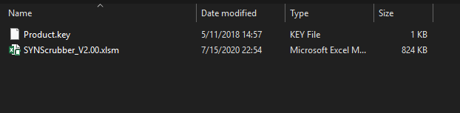

# Load Synchro Data

Since the SYNScrubber Tool can read *.CSV files that have been generated by Synchro, the first step is to transfer our data from Synchro model to CSV table.

Open the first Synchro model in your comparison. Click on “File” – “Save as” to open the data save window in Synchro. Save the file as the CSV format located in the scroll bar, with your preferred name and location. (Figure 3) Repeat this step with the second Synchro model file. It is recommended to use different file names to differentiate between models.

Figure 3. Save as CSV files in Synchro

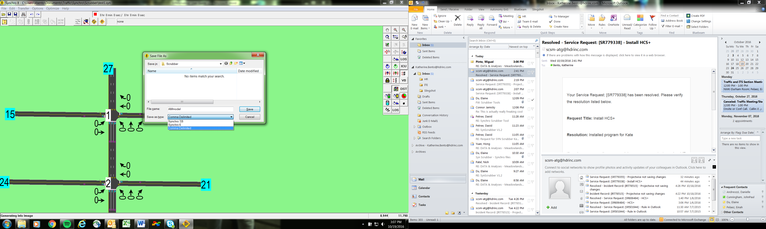

The intersection comparison will need to have a report created for the intersection results. The report setup is show in Figure 4. The report needs to be saved with the Synchro file name and append “_SYN.txt”.

Figure 4. Intersection Report Setup

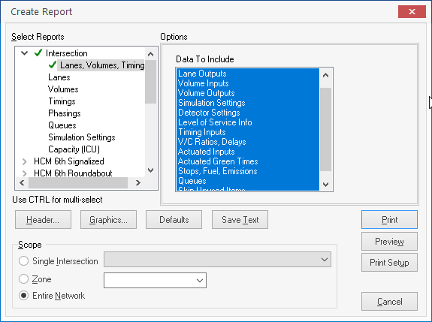

The arterial comparison will need to have the report created for arterial results. The report is shown in Figure 5. The report needs to be saved with the Synchro file name and “_art.txt”.

Figure 5. Arterial Report Setup

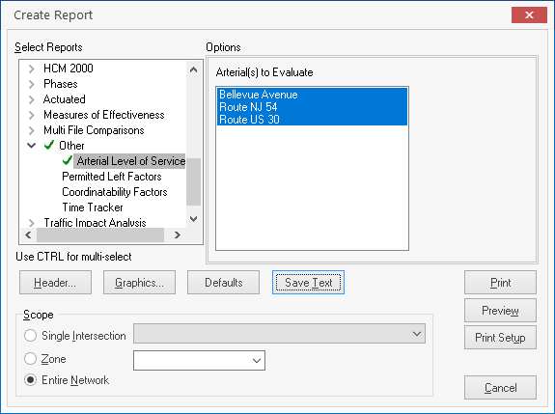

The files needed to run the SYNScrubber tool are a csv, intersection, and arterial result files. Figure 6 shows an example of files needed. The two sets of files can be saved into different folders but each Synchro file needs to have the complimentary files (csv, _art, _SYN) in the same folder. The tool will use the text before the character “_” in the file name and place in the top of the “Diffs” sheet.

Figure 6. Intersection Report Setup

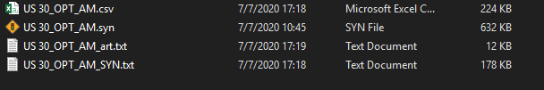

After both files are exported as CSV and additional files saved, the SYNScrubber tool can be used to compare them. The CSV comparison function is located under “ADD-INS” tab in Excel. (Figure 7)

Figure 7. CSV Comparison

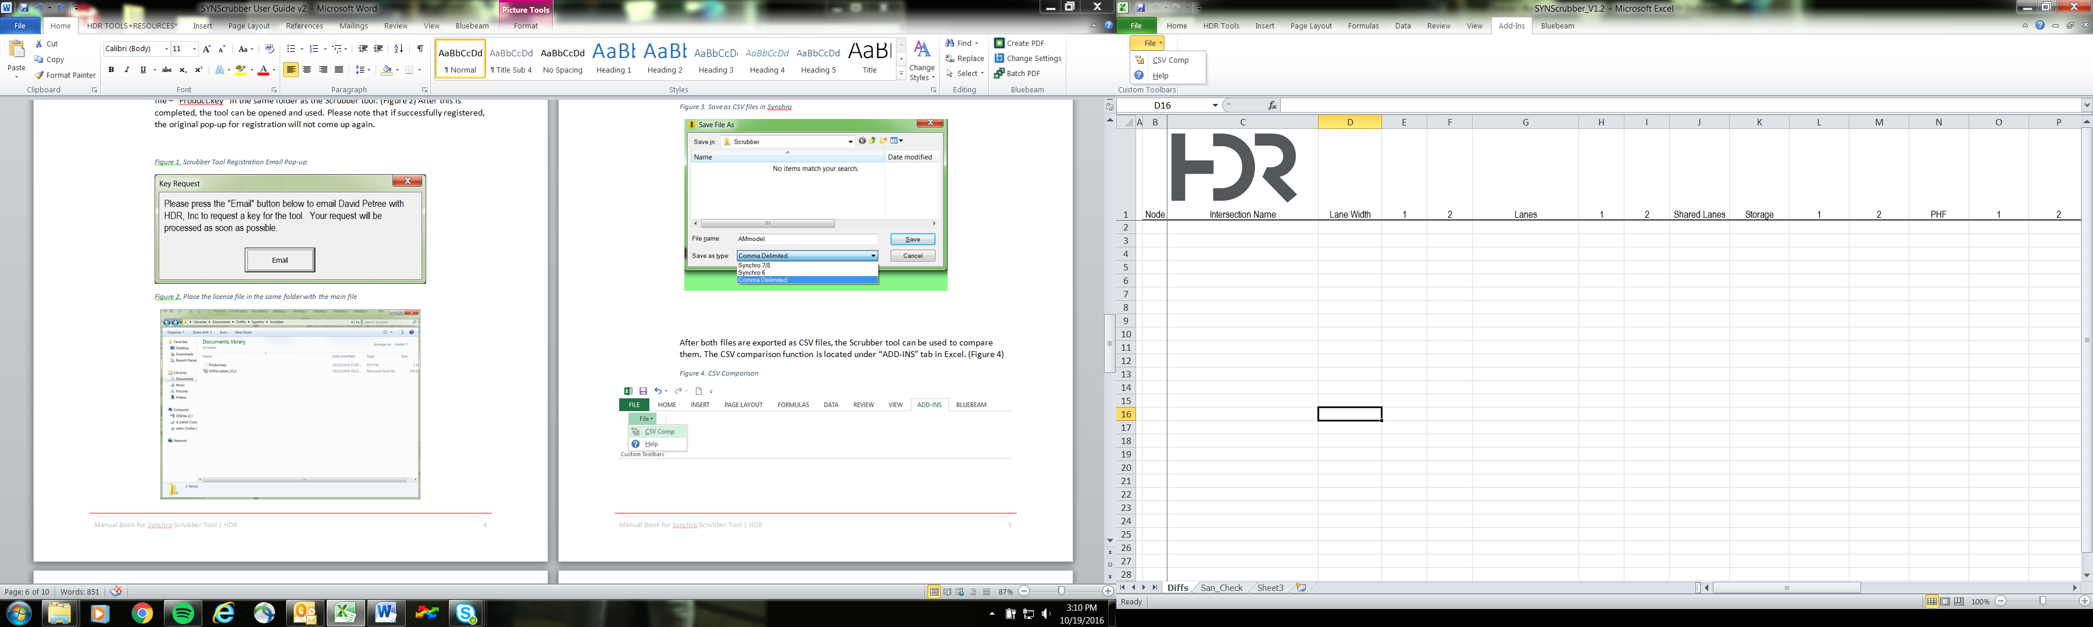

The pop-up will require input of both CSV files into Excel. The file label is optional and can be set to replace the column label in the final result table. To get the final results click on “Compare” at the bottom of the pop-up.

Figure 8. Import CSV file to the SYNScrubber tool

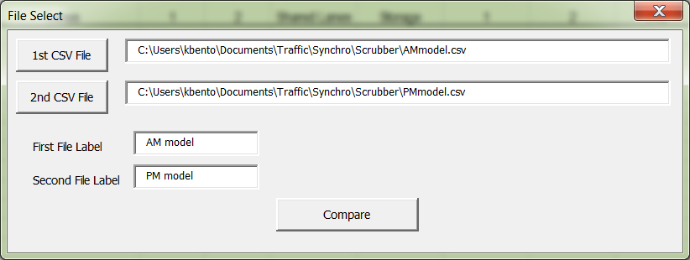

# Comparison Result

The SYNScrubber Tool will output the differences between the two models in the “Diffs” tab. The variable inputs compared using the SYNScrubber Tool include:

* Volume
* Conflicting Peds
* Conflicting Bikes
* Saturation Flow
* Lane width (ft)
* Lane settings
* Shared lanes
* Storage length (ft)
* PHF
* Link Speed (mph)
* Growth Factor
* Approach Grade
* Mid-Block Traffic
* %HV
* Lost time adjust
* Bus blockage
* Parking Maneuvers
* Cycle Length (s)
* Turn type (Protected/Permitted Phasing)
* Phasing
* Phase lengths (s)
* Offset (s)
* Yellow (s)
* Red (s)
* Walk (s)
* Don’t Walk (s)

The Intersections tab will output the following by intersection movements:

* Delay (s)
* Level of Service (LOS)
* Lane Utilization Factor
* Left Turn Factor (Permitted)
* Right Turn Factor.

The Arterials tab will output the following by arterial link:

* Travel Time (s)
* Delay (s).

The differences that are observed between the two models can be seen in Figure 9. The SYNScrubber Tool bases the comparison on intersection level parameters and includes three columns for each factor. The first column is labeled with the factor name and tells which movement has difference at each intersection. The second and third columns are labeled with the titles of model one and model two respectively and show the difference in values. The figures for each movement are separated by commas in each cell and follow the order of the movements listed in the first column.

Figure 9. Comparison Result

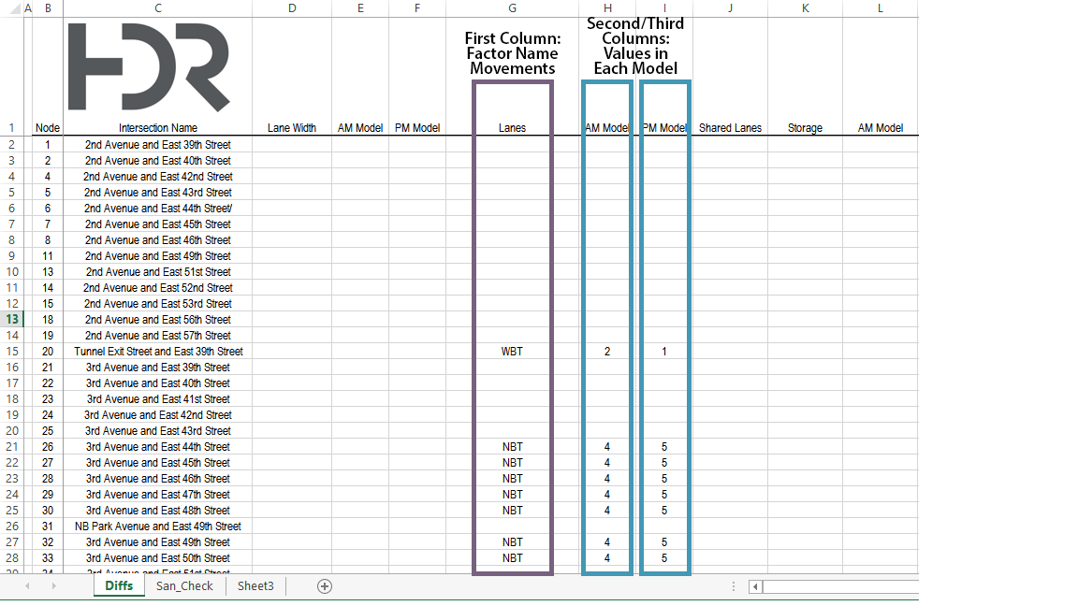

The Scrubber Tool will also check the PHF, heavy vehicle percentages, lane width, saturation flow, volume/capacity ratio, 50th percentile and 95th percentile queues for each model to ensure that they fit the preset acceptable ranges in the “San_Check” tab. (Figure 10) The following checks are reported:

* PHF less than 0.85
* Heavy Vehicle Percentage 0%
* Lane Width is less than 7 feet
* Saturation Flow is not 1900
* Lost Time Adjustment is not 0
* Approach Grade is not 0
* Traffic From Mid-Block is not 0
* Bus Blockage is not 0
* Enter Blocked Intersection is not No
* Parking Manuevers is not 0
* Conflicting Pedestrians is not 0
* Right Turn on Red is Not Allowed
* Walk Time is less than 7 seconds
* Yellow Time is less than 3 seconds
* Red Time is less than 2 seconds
* Volume/Capacity Ratio indicates Defacto Left
* Volume/Capacity Ratio indicates Defacto Right
* 50th Percentile Queue contains “~”
* 95th Percentile Queue contains “#”

Figure 10. Preset Value Sanity Check

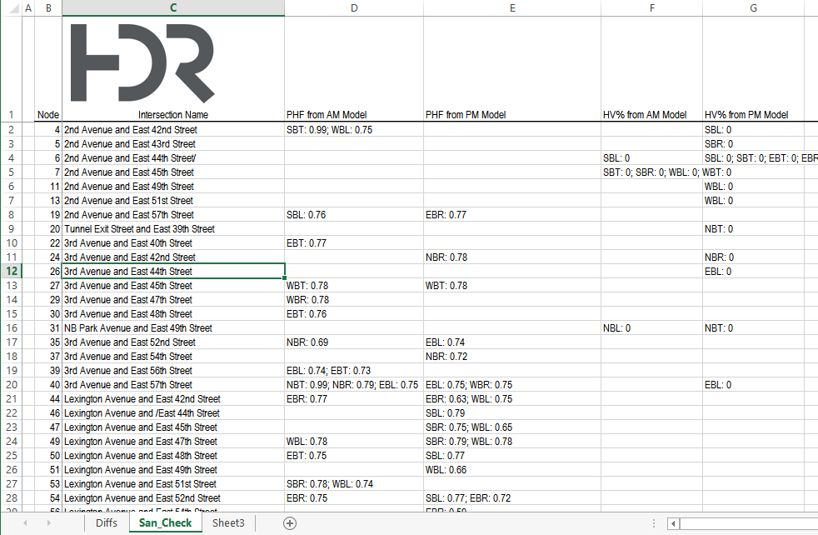

Check that all the differences are reasonable and save this comparison table as an Excel file for future review.

If you have any questions or issues regarding the Scrubber Tool, please contact Nish Patel ([Nish.Patel@hdrinc.com](mailto:Nish.Patel@hdrinc.com)) or David Petree ([David.Petree@hdrinc.com](mailto:David.Petree@hdrinc.com)).